Library Name: | cgm
Cell Name: | XOR2XI
Function/Truth Table:
A B |  | Y
0 0 |  | 0
0 1 |  | 1
1 0 |  | 1
1 1 |  | 0
Propagation Delay (path based):
Transition |  | Delay (s)
A → Y ↑ (T_PLH) |  | 1.282n
A → Y ↓ (T_PHL) |  | 1.774n
B → Y ↑ (T_PLH) |  | 1.283n
B → Y ↓ (T_PHL) |  | 1.789n
Output Rise Time (path based):
Transition |  | Rise Time (s)
A → Y ↑ |  | 2.469n
B → Y ↑ |  | 2.465n
Output Fall Time (path based):
Transition |  | Fall Time (s)
A → Y ↓ |  | 3.384n
B → Y ↓ |  | 3.422n
Layout Height:
Layout Width:
Layout Area:
Symbol with Port Names:

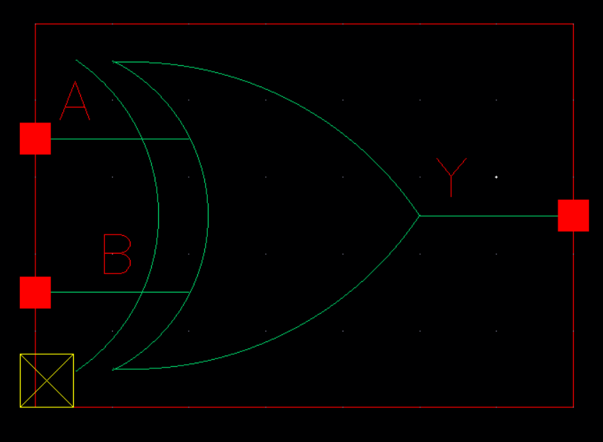
Schematic:

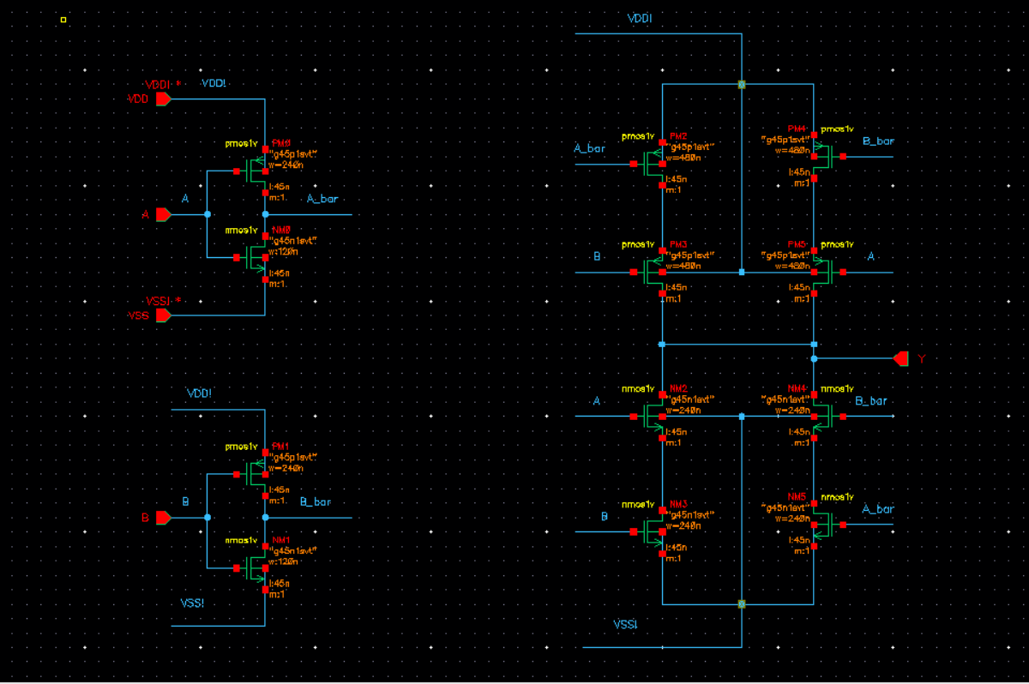
Layout:
Functional Simulation Waveforms

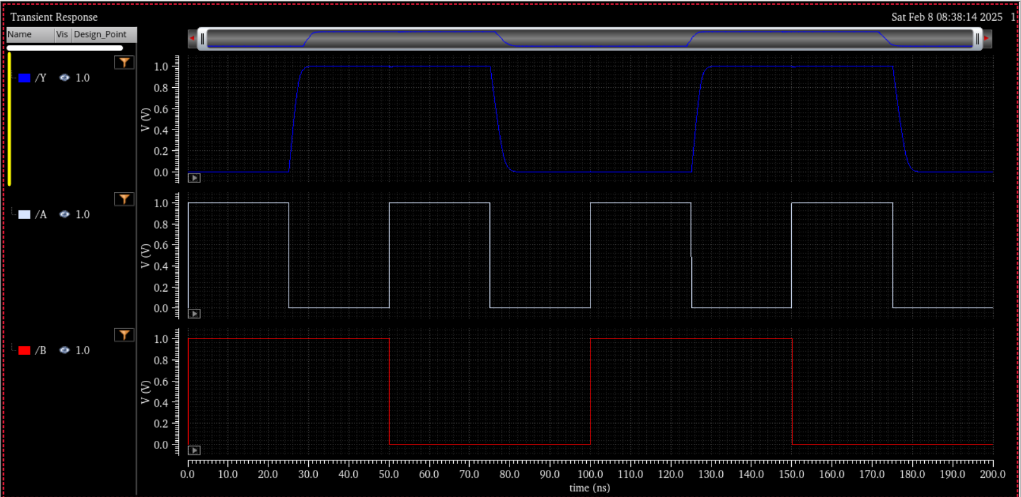

Comments/Notes:

The results indicate that the XOR gate functions as expected.
The propagation delays are within acceptable limits.
Functional simulation verified correct logic operation.

